Analysis of Muon Flux Across Altitude
Michael Winchester
Mentors: Matthew Semak, Ph.D.; David Garrett, Amber Bekalli, and Maurice Woods III
Frontiers of Science Institute 2014
University of Northern Colorado

Abstract
Cosmic rays are produced by supernovae, the sun, and other explosions in the upper atmosphere. These cosmic rays are constantly impacting atomic nuclei which produces particles called pions. These pions decay very quickly into particles called muons. Muons have a mass that is 200 times that of an electron, which allows them to travel 99 percent the speed of light. Due to this, the muons can penetrate deep into Earth’s atmosphere and can sometimes even reach the surface. A device called a Geiger counter can be used to detect these muons as they enter the atmosphere. Using an altimeter to measure the altitude, the Geiger counter will measure the muon flux as it relates to altitude in the atmosphere. To measure the muon count as it correlates to altitude, the payload will be launched 30 km into the atmosphere with a weather balloon.
Introduction
Cosmic rays are constantly impacting atomic nuclei and other molecules in the upper atmosphere, producing pions. Within meters of traveling, these pions decay into muons and muon neutrinos (Houseman 1999). A muon neutrino is a muon but has a neutral charge, while a muon has a negative charge, similar to electrons. These muons have 200 times the mass of an electron but they only interact with the surrounding matter via ionization. Ionization is the process in which an atom or molecule gains a positive or negative charge by gaining or losing electrons to form ions. The loss of energy by muons passing through the atmosphere is proportional to the amount of matter they traverse (Muon Basics, 2014). These muons travel at 99 percent of the speed of light, which allows them to experience time much slower due to relativity. According to relativity and the fact that muons travel at such a high velocity it is expected that muon be time-dilated and decay more slowly. This allows them to survive longer while in Earth’s frame of reference. These two factors allow them to travel very far into Earth’s atmosphere and sometimes they can even reach the surface (Liu, 2014). On average, 10,000 muons reach every square meter of the Earth’s surface each minute. Since muons do not interact with matter as much as other particles, they are able to penetrate through rocks and other matter before losing their momentum (Muon Basics, 2014). As the muons continue traveling towards Earth, their rate of decay relates directly to altitude (1). A Geiger counter, which will also be on the payload recording data throughout the flight, is a device that detects ionizing radiation, including muons. To measure the altitude, we will be using an altimeter. This altimeter indirectly measures altitude. The altimeter takes measurements of temperature and pressure, and since they are proportional to altitude, the altitude can be derived. The altimeter will measure the altitude while the Geiger counter measures the muon flux as they correlate. The payload will be sent up about 30 km into the atmosphere so the Geiger counter and altimeter can measure the muon flux that correlates with altitude. Since the payload is being sent 30 km into the atmosphere, the temperature will begin to get very cold, so the payload has to be suited for extreme temperatures. At about 30 km up, the temperature will be about -50 degrees Celsius, which means that the payload will need to be heated (Russell, 2009). The COSGC (Colorado Space Grant Consortium) that runs the Demosat program set a maximum weight for the payload so the balloon can hold all the modules. The balloon has to hold payloads built from other schools as well as the payloads from our team. The payload can also only hold 1.5 kg of weight to make sure the balloon can hold the weight and lift the whole module. All of the tools on the payload will need to be kept relatively warmer than the outside temperature. To do this, the payload will have fiberglass insulation on the inside, as well as a heater to keep all the tools working properly. The payload is coated in a layer of aluminum foil to keep the box protected against the elements such as rain and snow.

Materials
For this project, it is not only important to have a weather balloon to lift the payload to thirty km, but also many instruments are needed to measure and record the data. The payload will be launched with one of two 3,000 gram latex, helium-filled balloons to reach the desired altitude. These weather balloons are designed to reach 30 km in altitude and can carry multiple payloads that will each weigh 1.5 kg. The payload most inner layer is a thick layer of lightweight foamcore which is the payload’s base (Figure 12). In the payload there will be a heating system comprised of six 9V batteries, six 1 kohm resistors, and coated wires. The mass of the heating system will be .4 kg. The heating system keeps the electrical components of the payload warm. At an altitude of 30 km, in the stratosphere, the temperature will be around -50 degrees Celsius. The batteries provide the heater with power to maintain a sufficient temperature in the payload. The Sparkfun Geiger counter measures many high energy particles, including muons. This will weigh .05 kg and is 4 by 2 in. The Geiger counter will be encased in a PVC pipe to provide electrical insulation to prevent coronal arcing, a payload-damaging phenomenon experienced by high voltage devices such as the Geiger counter (Figure 6). The BMP180 Pressure Sensor measures pressure and temperature, which can both be used to determine altitude. The sensor weighs .1 kg and is .5 by .5 in. The Arduino Uno is a microcontroller board that will have both of these instruments connected to it. It runs the data collection routine to record the signal produced by the Geiger counter and the sensor and stores it on a SD card. The arduino weighs .05 kg and is 3 by 2 in. Arduino is a scripting language that will take the information from the two systems and store the data on an SD card (Figure 8). The SD card will be in a Sparkfun MicroSD shield which will allow the data from the flight to be stored on the Arduino, giving it storage space and allowing the data to be manipulated and moved. The SD card will then be accessed after the flight so the data can be recorded and later interpreted after the payload is recovered.
Another defense against the harsh temperatures is the fiberglass insulation that lines the inside of the payload. The payload is also covered in aluminum foil to provide extra structural support and enhance the aesthetics of the payload. A space blanket is another layer of thermal insulation to keep the inside of the payload warm. The temperatures get really cold when the payload is thirty km up which is the reason the payload has so much insulation. Refer to Figure 13 to see the box which has completed layers, but lacks all its electrical components.
Methods
To get the payload in the air, it's much more than just launching the balloon with the payload attached. There is a lot of testing with either instruments or the payload itself before it can be launched. The center of gravity has to be in the center so the payload does not fall at an odd angle. This would interfere with the flight and landing and might damage the instruments. The heater has to be tested multiple times so it works properly. The heater has to produce enough electricity to power the payload for the entire three hour flight so the instruments can record data for entire duration. The heater must spread its use of electricity out over time so as not to use too much power too fast. The code for the arduino has to be written and must work correctly so the data can be accessed after the flight. The Geiger counter must work correctly so the data is precise and reliable. The sensor must run smoothly and gather data precisely. After the instruments are all assumed to be working correctly, the box needs to be tested. The temperature can be tested by using liquid nitrogen, which has a temperature of -196 degrees Celsius. The payload can be submerged to see if the heater provides sufficient heat for the payload and all the other components in the cold temperatures. The parachute can be tested by dropping the box of a building or some other large height. The adhesive that holds the material together must be tested to see if it can hold together the material even in the extreme temperatures.
After all the tests have been run and all the instruments work properly, the payload can be launched. The balloon will be sent up carrying the payload to about 30 km into the stratosphere. After the balloon reaches its maximum height, the balloon will pop and soon after, the parachute will deploy. The parachute will allow the payload to fall back to the surface and the experimenters will follow and retrieve the payload after it lands. After the entire flight is over, the SD card can be taken from the SD shield and the recorded data can be retrieved. The data can be interpreted and read to find what the experimenters are looking for.
Results
To make sure all the instruments would work properly, many tests had to be performed. A temperature test was conducted to see how the heater worked under the cold conditions and see if it could provide enough heat and energy to keep the payload warm. The batteries seemed to fall a bit below the standard for the recommended temperature (Figure 1). This is due to the fact that we were testing with liquid nitrogen which has a temperature of -196 degrees Celsius. At 30 km the temperature will only be -50 degrees Celsius. If the experiment were done again, a better way to simulate the actual temperature up at 30 km would have been to test with dry ice because it has a temperature of -80 degrees Celsius. The heater had to work properly and the electricity had to run through the series and parallel set of batteries to make sure the resistors were giving off heat (Figure 7). To test our hypothesis on what the muon flux should be with a change in altitude, we constructed a “test box” with the Geiger counter. The box was brought from Greeley, CO (4,675ft) to Spearhead Peak in Rocky Mountain National Park (12,575ft). The box lasted the entire duration of the hike and collected five hours worth of data. The data seemed to match up to what we predicted it should of been (Figure 4).
The pressure sensor was tested by visiting different floors using a elevator (Figure 10). This test simulates the altitude change when the payload is actually launched. The altitude changes as the payload is moved from floor to floor (Figure 2). After this test had occurred the data needed to be extracted from the SD card and recorded on the computer. The SD card was removed from the micro SD shield and inserted into the computer to record the results (Figure 9). The whip test was conducted to simulate turbulence and see how the payload handles turbulence. The instruments were held in place and did not take too much damage.The drop test was conducted to simulate the impact from the landing after almost the entire of the flight had ended. The payload handled the impact well after dropping it off a building and also the payload will have a parachute to help slow its descent.
Discussion
The payload did very well in all the tests we conducted, save for the temperature test; The temperature of liquid nitrogen is more than twice as cold as the temperatures found in the stratosphere. Testing the payload and heater with dry ice could have given us more realistic results, since dry ice is roughly the same temperature as the stratosphere, but typical environmental testing procedures mandate that payloads be subject to extreme conditions. Since the tests all went well, the payload is expected to do very well on the actual flight. If the instruments are jumbled up during the flight, which we saw in small detail after some of the tests, damages can be fixed by using plastic cement, industrial glue, solder etc. The payload is expected to bring back results similar to the experiment in Figure 3, but we will have much more data, as we are going much higher in the stratosphere (Ramesh 2011).
There is still more to be known about muons and muon neutrinos, so new experiments have to be conducted. Studying muons and other cosmic rays will give us a better description of Earth’s upper atmosphere and what goes on. In later experiments, people could test even higher into the atmosphere or even deeper into Earth’s core.

Figures

Figure 1

This graph shows the data from the temperature test. The green line represents the temperature probe that was inside the payload, next to the heater. The orange line represents the temperature probe that was inside the payload, but not next to the heater. The blue line represents the temperature probe that was outside the payload but in the styrofoam box. The styrofoam box housed the payload so the temperature of the liquid nitrogen was not disturbed by the room temperature.

Figure 2

This graph shows the data picked up by the Geiger counter when it was tested by visiting different floors using a elevator. This test simulates the altitude change when the payload is actually launched. The altitude changes as the payload is moved from floor to floor.

Figure 3

This is the results from another payload project that also tested for muon flux. This shows the muon flux as the altitude increases which is a similar study to what we are doing.

Figure 4
This graph represents the muon flux from Greeley, CO to Rocky Mountain National Park. The Geiger counter was brought in a “test box” in order to test it and see if our hypothesis was on the right track. The data seems to match what we predicted it would. The count increases as the elevation increases.

Figure 5

This figure shows the circuit orientation of the heater. The heater has two sets of batteries (four each) in parallel. The heater has 6 power resistors which produces the heat in order to keep the payload warm.

Figure 6

This is the Geiger counter. This device detects high energy radiation. In this experiment we used it to measure muons at high altitudes.

Figure 7

This is the heater that is in the payload. The heater provides the heat for the payload. The instruments cannot get too cold or they will not work. The heater makes up for the cold temperatures at high altitudes and keeps the payload and the instruments warm.

Figure 8

This is the Arduino Uno. This is a microcontroller board that provides power to the other components on the payload. It also runs the data collection routine in order for the information to be accessed after the flight.

Figure 9

This is the micro SD shield. This will be connected to the Arduino Uno which gives it power and sends it data. The data will be saved on a SD card that is in the micro SD shield using power from the Arduino. After the flight is over, the SD card can be taken and inserted into a computer and the data can be recorded and interpreted.

Figure 10

This is the sensor that records the pressure and temperature. The sensor is connected to the micro SD shield so the Arduino gives it power to record data. The data will be stored on the SD card.

Figure 11

This is the payload while under construction. Although it is not finished, this shows the layers of material that are used to keep the payloads’ instruments inside. The actual box is made of foamcore, which encloses the box and all of its insides. The next layer is fiberglass insulation that keeps the box warm. The last layer is the aluminum tape that enhances the structural strength and aesthetics of the payload.

Figure 12

This is the foamcore that provides the payload with its first layer of protection against the temperatures and other elements that might occur at thirty km in the stratosphere.

Figure 13
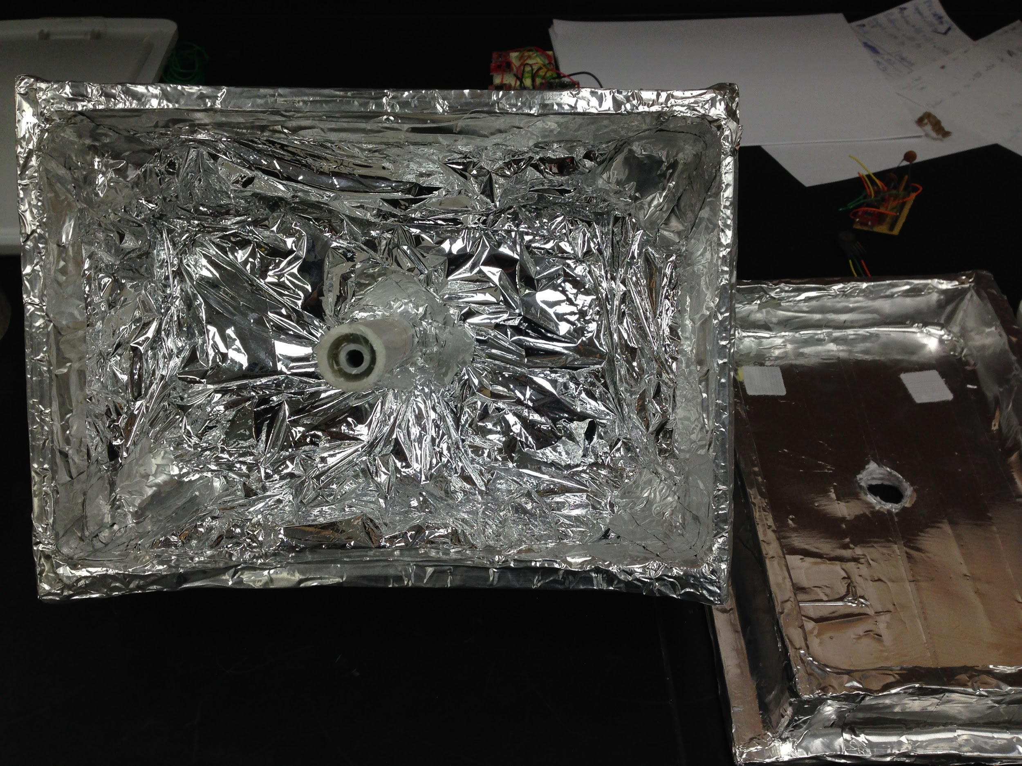
This is the completed box without all the electrical components. The space blanket is covering the entire outside surface of the box which serves as another layer of thermal insulation. The PVC pipe in the middle provides a way to string the module up on the flight string.

Figure 14
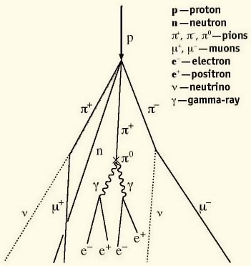
This diagram shows the transformation of cosmic rays that come in from the top as they decay into pions then into muons.

Works Cited
Cosmic Ray Muons and the Muon Lifetime. (2013, October 14). Retrieved July 17, 2014, from http://www.phys.ufl.edu/courses/phy4803L/group_I/muon/muon.pdf
Houseman, J. & Fehr, A. (1999, October 12). Listening For Cosmic Rays. Retrieved July 22, 2014, from http://neutronm.bartol.udel.edu/listen/main.html
Liu, L., & Solis, P. (2007, November 18). The Speed and Lifetime of Cosmic Ray Muons. Retrieved July 17, 2014, from http://web.mit.edu/lululiu/Public/pixx/not-pixx/muons.pdf
Muon basics. (n.d.). . Retrieved July 17, 2014, from http://www2.fisica.unlp.edu.ar/~veiga/experiments.html#mass
Ramesh, N., Hawron, M., Martin, C., & Bachri, A. (2011, January 1). Flux Variation of
Cosmic Muons. Retrieved July 18, 2014, from http://arxiv.org/pdf/1203.0101.pdf
Russell, R. (2009, March 30) Temperature in the Stratosphere. Retrieved July 22, 2014, from
http://www.windows2universe.org/earth/Atmosphere/stratosphere_temperature.html
Schirber, M. (2009, August 27). Death Rays From Space: How Bad Are They? Retrieved July 17,
2014, from http://www.space.com/7193-death-rays-space-bad.html
U.s. standard atmosphere. In (2012). W. Haynes (87 Ed.), CRC Handbook of Chemistry and
Physics (pp. 14-19, 14-25). Retrieved from http://www.hbcpnetbase.com/

